**Ideation Phase**

**Define the Problem Statements**

|  |  |
| --- | --- |
| Date | 01 July 2024 |
| Team ID | SWTID1719999205 |
| Project Name | Darshan Ease: Your Effortless Path to Divine Sight |
| Maximum Marks | 3 Marks |

**Customer Problem Statement Template:**

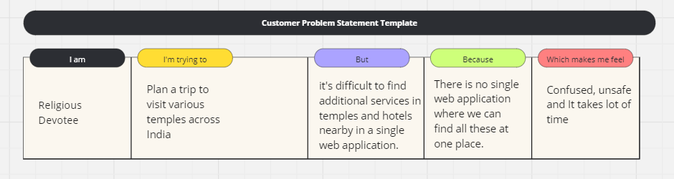

Problem Statement:

I am a Religious Devotee, I'm planning a trip to visit various temples across India. I'm looking for a single web application that would allow me to:

1. Book visits to different temples in various locations throughout India
2. Reserve hotels near these temples
3. Arrange for additional services offered at each temple

Currently, there's no single website that provides all these facilities in one place. Which makes me feel confused, unsafe and it takes a lot of time.